36.19: a) 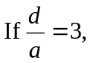 then there are five fringes: 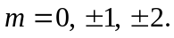
b) The 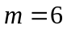 interference fringe coincides with the second diffraction minimum, so there are two fringes 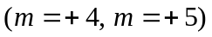within the first diffraction maximum on one side of the central maximum.

